Programming Fundamentals Lab

Lab Assignment 06

Course Code: CL1002

Syed Muhammad Shuja Ur Rahman

Roll No. 22K-4456

Ms. Ayesha Ali

Task 01

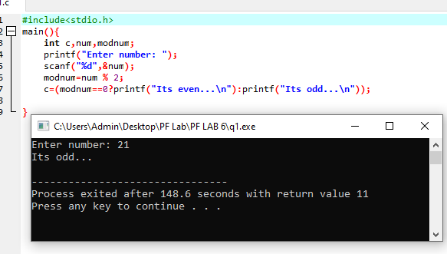Find out the given number is even or not using Ternary Operator in C.

Task 02

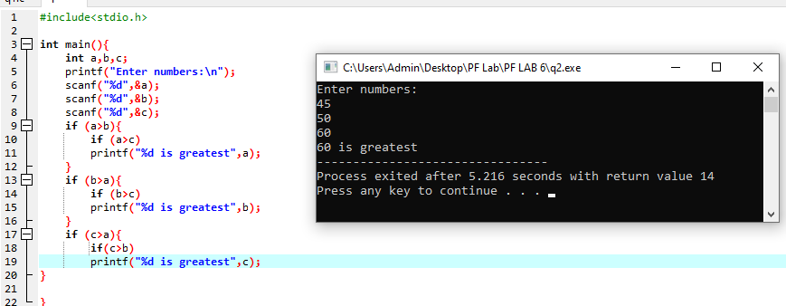Write a program to find the greatest number among three numbers using nested if else.

Task 03

Rewrite the following program segment using the if-else statements instead of the ternary operator.

String grade = (mark >= 90) ? “A” : (mark >= 80) ? “B” : “C”);

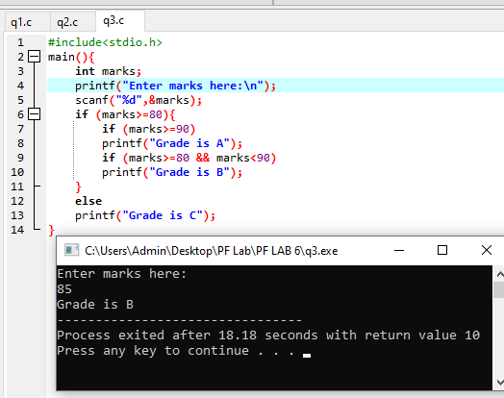

Task 04

A restaurant named SandwichesTown makes sandwiches. You order a sandwich and you're asked what kind

of sandwich you would like: chicken, beef or vegetarian. You select vegetarian and you're asked to select

from a choice of three vegetarian combinations:

* Tomato and mozzarella
* Eggplant and parmesan
* Cucumber and Swiss cheese

In this case when you choose chicken or beef you have no more choices to make. But when you choose

vegetarian, you'd then have to choose what kind of vegetarian sandwich you like. Write a program to

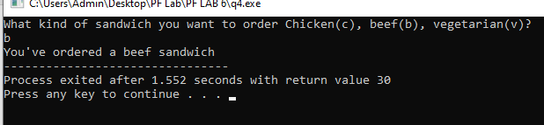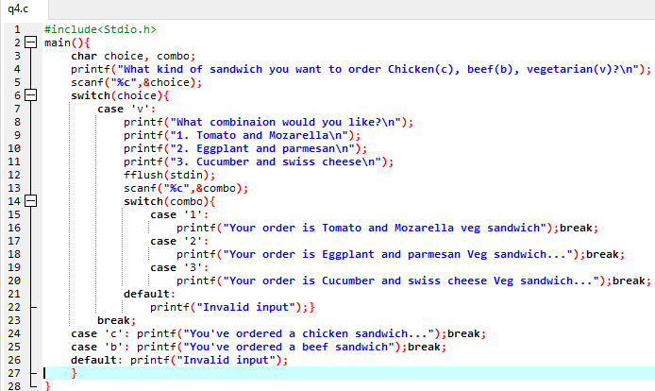implement these procedures.

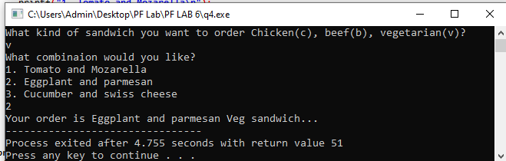

Task 05

A leap year is a year that has 366 days, instead of 365 days. It has one day extra in the month of February.

Leap years occur once in 4 years, so any year that is completely divisible by four should be a leap year. But

this is not always true. If there is some year and it is divisible by hundred, it will be a leap year only if it is

also divisible by four hundred. Given a year, check if it a leap year or not using nested if else statement.

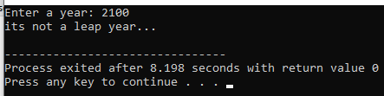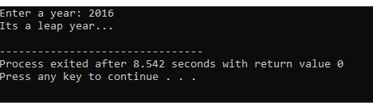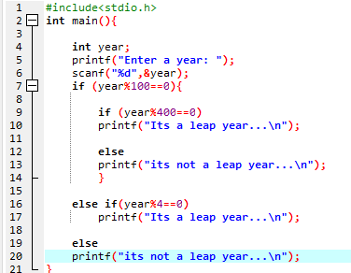

Task 06

Check whether the triangle is equilateral, scalene, or isosceles.

• Isosceles triangle: In geometry, an isosceles triangle is a triangle that has two sides of equal length.

• Equilateral triangle: In geometry, an equilateral triangle is a triangle in which all three sides are

equal.

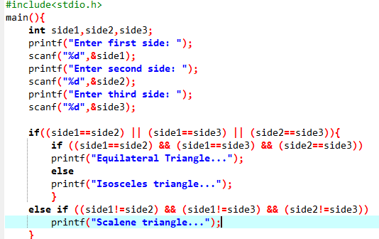• Scalene triangle: A scalene triangle is a triangle that has three unequal sides.

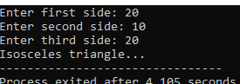

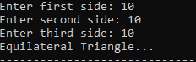

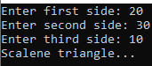

Task 07

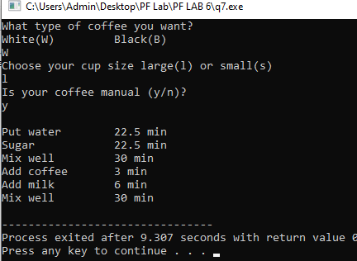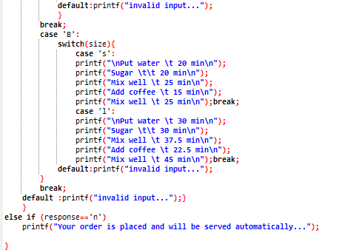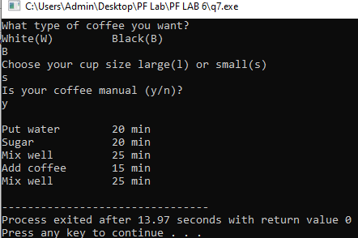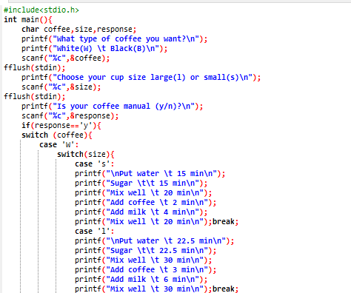Write a program to control a coffee machine….

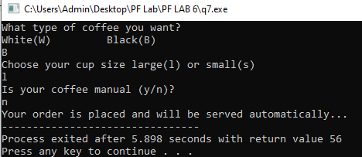

Task 08

You are searching for a department in a university and you’re asked to select a school from a choice of three

* School of Computer Science
* School of Business
* School of Engineering

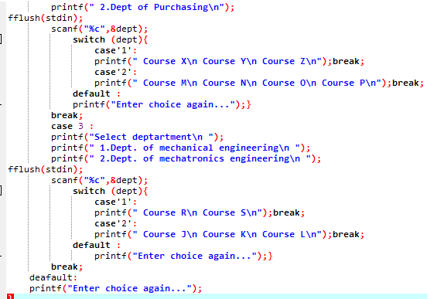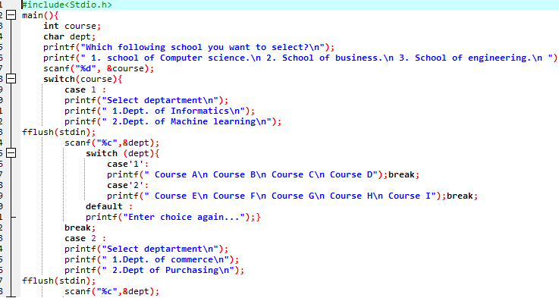… Write a program to make the above logic implementable.

**Task 08 Output on next page…**

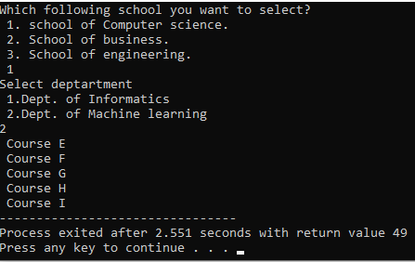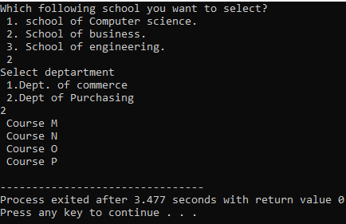

Task 09

Mortgage Calculator) Develop a C program to calculate the interest accrued on a bank customers mortgage.

For each customer, the following facts are available:

a) the account number

b) the mortgage amount

c) the mortgage term

d) the interest rate

The program should input each fact, calculate the total interest payable (= mortgage amount × interest rate ×mortgage term), and add it to the mortgage amount to get the total amount payable. It should calculate the required monthly payment by dividing the total amount payable by the number of months in the mortgage term. The program should display the required monthly payment rounded off to the nearest dollar. The program should process each customer’s account at a time. Here is a sample input/ output dialog:

Enter account number (-1 to end): 100

Enter mortgage amount (in dollars): 6500

Enter mortgage term (in years): 3

Enter interest rate (as a decimal): 0.075

The monthly payable interest $ 221

Enter account number (-1 to end): 200

**Task 09 output on next page…**

